Name : Muhammad usama.

Section : B.

Roll no. :17f_8195.

Lab : 5.

Task 1:

#include<iostream>

using namespace std;

struct Distance

{

int feet;

float inchies;

};

struct volum

{

Distance length;

Distance width;

Distance hight;

};

void housevol(float volume,float l,float w,float h);

int main()

{

float volume=0,l=0,w=0,h=0;

housevol(volume,l,w,h);

system("pause");

return 0;

}

void housevol(float volume,float l,float w,float h)

{

volum house;

cout<<"eneter the length of house in feet : ";

cin>>house.length.feet;

cout<<"eneter remaining inchies of house length : ";

cin>>house.length.inchies;

cout<<"eneter the width of house in feet : ";

cin>>house.width.feet;

cout<<"eneter remaining inchies of house width : ";

cin>>house.width.inchies;

cout<<"eneter the hight of house in feet : ";

cin>>house.hight.feet;

cout<<"eneter remaining inchies of house hight : ";

cin>>house.hight.inchies;

l=house.length.feet+(house.length.inchies)/12;

w=house.width.feet+(house.width.inchies)/12;

h=house.hight.feet+(house.hight.inchies)/12;

volume=l*w*h;

cout<<"volume of house is : "<<volume<<endl;

}

Result:

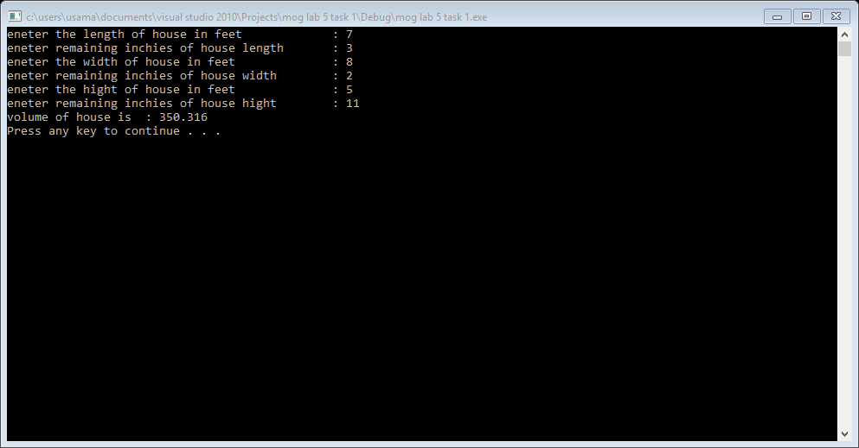

Task 2:

#include<iostream>

#include<string>

using namespace std;

struct drinkmachine

{

string name;

int cost;

int NOfDrinks;

};// machine;

int main()

{

char chose;

string ok;

int amount=0;

bool flage=true;

char more={0};

drinkmachine *ptr;

ptr=new drinkmachine[4];

(ptr+0)->cost=75;

(ptr+0)->name="cola";

(ptr+0)->NOfDrinks=20;

(ptr+1)->cost=75;

(ptr+1)->name="root beer";

(ptr+1)->NOfDrinks=20;

(ptr+2)->cost=80;

(ptr+2)->name="grape soda";

(ptr+2)->NOfDrinks=20;

(ptr+3)->cost=80;

(ptr+3)->name="cream soda";

(ptr+3)->NOfDrinks=20;

while(flage==true)

{

cout<<" press c for : "<<(ptr+0)->name<<endl;

cout<<" press r for : "<<(ptr+1)->name<<endl;

cout<<" press g for : "<<(ptr+2)->name<<endl;

cout<<" press m for : "<<(ptr+3)->name<<endl;

cout<<" press e for exit"<<endl;

cin>>chose;

cout<<"total amount in the machine : "<<amount<<endl;

if(chose=='c'||chose=='C')

{

cout<<"no of cola drinks left :"<<(ptr+0)->NOfDrinks<<endl;

cout<<"amount of drink :"<<(ptr+0)->cost<<endl;

if((ptr+0)->NOfDrinks!=0)

{

cout<<"press ok for buy drink"<<endl;

cin>>ok;

if(ok=="ok")

{

(ptr+0)->NOfDrinks=(ptr+0)->NOfDrinks-1;

amount=amount+75;

cout<<"now total amount in machine is : "<<amount<<endl;

cout<<"no of cola drinks left :"<<(ptr+0)->NOfDrinks<<endl;

cout<<"if you want to buy more drinks press m "<<endl;

cin>>more;

if(more=='m')

{

chose='0';

system("cls");

flage=true;

}

else

{

flage=false;

}

}

}

else

{

cout<<"there is no drink avaliable"<<endl;

}

}

if(chose=='r'||chose=='R')

{

cout<<"no of root bear left :"<<(ptr+1)->NOfDrinks<<endl;

cout<<"amount of drink :"<<(ptr+1)->cost<<endl;

if((ptr+1)->NOfDrinks!=0)

{

cout<<"press ok for buy drink"<<endl;

cin>>ok;

if(ok=="ok")

{

(ptr+1)->NOfDrinks=(ptr+1)->NOfDrinks-1;

amount=amount+75;

cout<<"now total amount in machine is : "<<amount<<endl;

cout<<"no of root bear left :"<<(ptr+1)->NOfDrinks<<endl;

cout<<"if you want to buy more drinks press m "<<endl;

cin>>more;

if(more=='m')

{

chose='0';

system("cls");

flage=true;

}

else

{

flage=false;

}

}

}

else

{

cout<<"there is no drink avaliable"<<endl;

}

}

if(chose=='g'||chose=='G')

{

cout<<"no of grape soda left :"<<(ptr+2)->NOfDrinks<<endl;

cout<<"amount of drink :"<<(ptr+2)->cost<<endl;

if((ptr+1)->NOfDrinks!=0)

{

cout<<"press ok for buy drink"<<endl;

cin>>ok;

if(ok=="ok")

{

(ptr+2)->NOfDrinks=(ptr+2)->NOfDrinks-1;

amount=amount+80;

cout<<"now total amount in machine is : "<<amount<<endl;

cout<<"no of root bear left :"<<(ptr+2)->NOfDrinks<<endl;

cout<<"if you want to buy more drinks press m "<<endl;

cin>>more;

if(more=='m')

{

chose='0';

system("cls");

flage=true;

}

else

{

flage=false;

}

}

}

else

{

cout<<"there is no drink avaliable"<<endl;

}

}

if(chose=='m'||chose=='M')

{

cout<<"no of root bear left :"<<(ptr+3)->NOfDrinks<<endl;

cout<<"amount of drink :"<<(ptr+3)->cost<<endl;

if((ptr+3)->NOfDrinks!=0)

{

cout<<"press ok for buy drink"<<endl;

cin>>ok;

if(ok=="ok")

{

(ptr+3)->NOfDrinks=(ptr+3)->NOfDrinks-1;

amount=amount+80;

cout<<"now total amount in machine is : "<<amount<<endl;

cout<<"no of cream soda left :"<<(ptr+3)->NOfDrinks<<endl;

cout<<"if you want to buy more drinks press m "<<endl;

cin>>more;

if(more=='m')

{

chose='0';

system("cls");

flage=true;

}

else

{

flage=false;

}

}

}

else

{

cout<<"there is no drink avaliable"<<endl;

}

}

if(chose=='e'||chose=='E')

{

system("pause");

return 0;

}

}//while loop of flage ;

system("pause");

return 0;

}

Result:

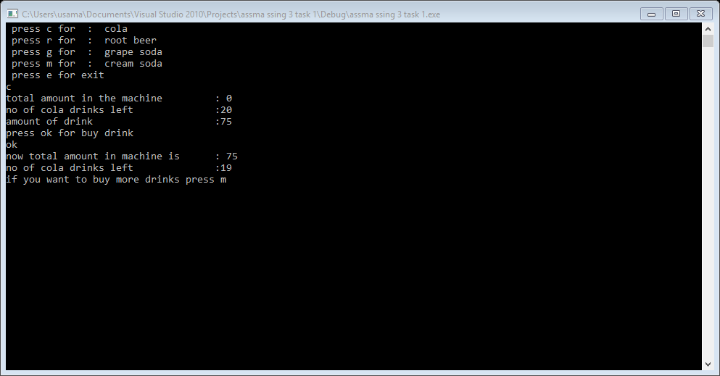

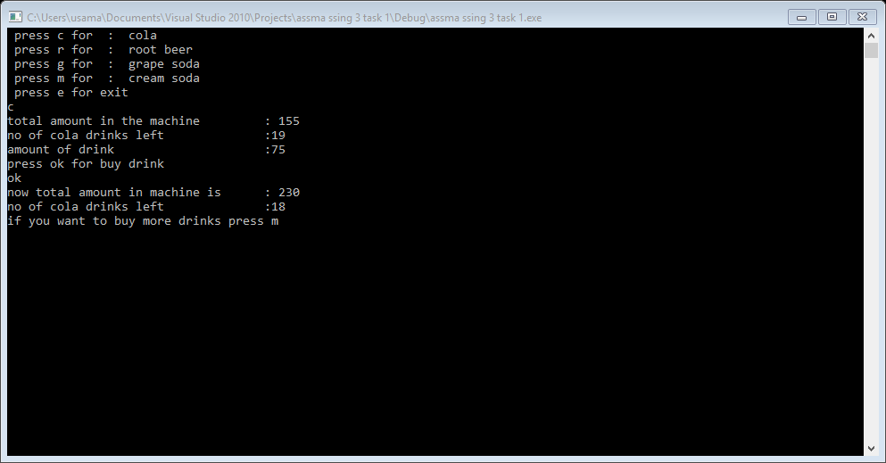

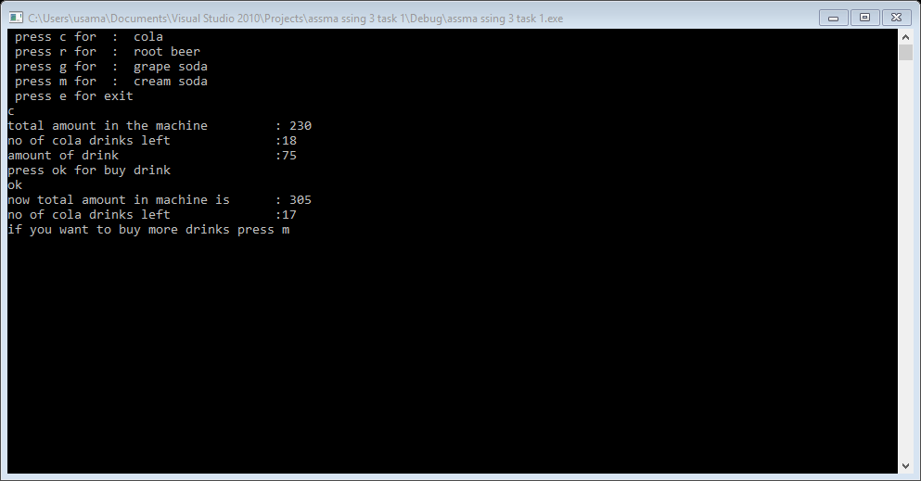

Task 3:

#include<iostream>

#include<string>

#include<fstream>

using namespace std;

struct player

{

string name;

int home_runs;

int hits;

};

void input(player arry[5]);

void output(player arry[5]);

void search(player arry[5]);

void save(player arry[5]);

int main()

{

char saven;

char update;

player arry[5];

input(arry);

output(arry);

cout<<"if you want to update the record press y \nother wise press n"<<endl;

cin>>update;

if(update=='y')

{

search(arry);

}

cin.ignore();

cout<<" if you want to save the rocord in file press s\n else press n"<<endl;

cin>>saven;

if(saven=='s')

{

save(arry);

}

cout<<endl;

system("pause");

return 0;

}

void input(player arry[5])

{

for(int i=0; i<5; i++)

{

cout<<"enter the name of "<<i+1<<" player : ";

cin>>arry[i].name;

}

for(int i=0; i<5; i++)

{

cout<<"enter the number of home runs of "<<arry[i].name<<" : ";

cin>>arry[i].home_runs;

}

for(int i=0; i<5; i++)

{

cout<<"enter the number of hits of "<<arry[i].name<<" : ";

cin>>arry[i].hits;

}

}

void output(player arry[5])

{

for(int i=0; i<5; i++)

{

cout<<i+1<<" player name : ";

cout<<arry[i].name<<endl;

}

for(int i=0; i<5; i++)

{

cout<<" home runs of "<<arry[i].name<<" : "<<arry[i].home_runs<<endl;

}

for(int i=0; i<5; i++)

{

cout<<"number of hits of "<<arry[i].name<<" : "<<arry[i].hits<<endl;

}

}

void search(player arry[5])

{

int chos=0;

int search=0;

cout<<"enter the plyer number of which you want to update the record : ";

cin>>search;

cout<<" you want to update the record of : "<<arry[search-1].name<<endl;

cout<<"press 1 for update home runs "<<endl;

cout<<"press 2 for update hits"<<endl;

cin>>chos;

if(chos==1)

{

cout<<" enter new home runs : ";

cin>>arry[search-1].home_runs;

}

else if(chos==2)

{

cout<<" enter new hits : ";

cin>>arry[search-1].hits;

}

else

{

cout<<"you enter invalid option"<<endl;

}

}

void save(player arry[5])

{

ofstream write;

write.open("usa.txt",ios::app);

if(write.is_open())

{

for(int i=0; i<5; i++)

{

write<<" home runs of "<<arry[i].name<<" : "<<arry[i].home_runs<<endl;

}

for(int i=0; i<5; i++)

{

write<<"number of hits of "<<arry[i].name<<" : "<<arry[i].hits<<endl;

}

}

else

{

cout<<"file not open"<<endl;

}

}

Result:

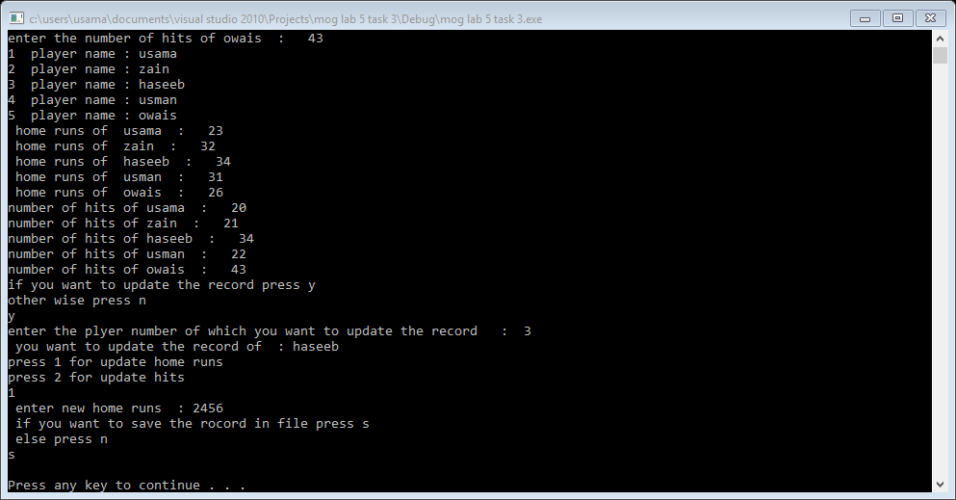

Task 4:

#include<iostream>

#include<string>

using namespace std;

struct student

{

string Fname;

string Lname;

int score;

char grade;

int cgpa;

};

void input(student *ptr, int size);

void grades(student *ptr, int size);

void highestScore(student *ptr, int size,int &adres);

//void highestcgpa(student *ptr, int size,int &adres);//redundancy because this work also done by highestscore function

void print_name(student *ptr, int size,int &adres);

int main()

{

int adres=0;

int size=0;

cout<<"how many student : ";

cin>>size;

student *ptr;

ptr=new student[size];

input(ptr,size);

grades(ptr,size);

highestScore(ptr,size,adres);

//highestcgpa(ptr,size,adres);

print_name(ptr,size,adres);

system("pause");

return 0;

}

void input(student *ptr, int size)

{

for(int i=0; i<size; i++)

{

cout<<"enter the First name of student "<<i+1<<" : ";

cin>>ptr[i].Fname;

cout<<"enter the Last name of student "<<i+1<<" : ";

cin>>ptr[i].Lname;

}

for(int i=0; i<size; i++)

{

cout<<"enter the test score of "<<ptr[i].Fname<<" "<<ptr[i].Lname<<" : ";

cin>>ptr[i].score;

}

}

void grades(student *ptr, int size)

{

for(int i=0; i<size; i++)

{

if(ptr[i].score>=90)

{

ptr[i].grade='A+';

ptr[i].cgpa=4;

}

else if(ptr[i].score=85)

{

ptr[i].grade='A';

ptr[i].cgpa=3.67;

}

else if(ptr[i].score>=80)

{

ptr[i].grade='B+';

ptr[i].cgpa=3.4;

}

else if(ptr[i].score>=75)

{

ptr[i].grade='B';

ptr[i].cgpa=3;

}

else if(ptr[i].score>=70)

{

ptr[i].grade='C+';

ptr[i].cgpa=2.6;

}

else if(ptr[i].score>=65)

{

ptr[i].grade='C';

ptr[i].cgpa=2.2;

}

else if(ptr[i].score>=50)

{

ptr[i].grade='D+';

ptr[i].cgpa=1.7;

}

else if(ptr[i].score>=40)

{

ptr[i].grade='D';

ptr[i].cgpa=1.3;

}

else if(ptr[i].score<40)

{

ptr[i].grade='F';

ptr[i].cgpa=0;

}

else

{

cout<<"invalid case"<<endl;

}

}

}

void highestScore(student *ptr, int size,int &adres)

{

int highest=0;

adres=0;

for(int i=0; i<size; i++)

{

if(highest<ptr[i].score)

{

highest=(ptr+i)->score;

adres=i;

}

}

}

/*void highestcgpa(student *ptr, int size,int &adres)

{

int highest=0;

cgpaadres=0;

for(int i=0; i<size; i++)

{

if(highest<ptr[i].cgpa)

{

highest=(ptr+i)->cgpa;

adres=i;

}

}

}*/

void print_name(student *ptr, int size,int &adres)

{

cout<<"highest score "<<ptr[adres].score<<" got by "<<ptr[adres].Fname<<" "<<ptr[adres].Lname<<" and cgpa of "<<ptr[adres].Fname<<" "<<ptr[adres].Lname<<" "<<ptr[adres].cgpa<<endl;

}

Result:

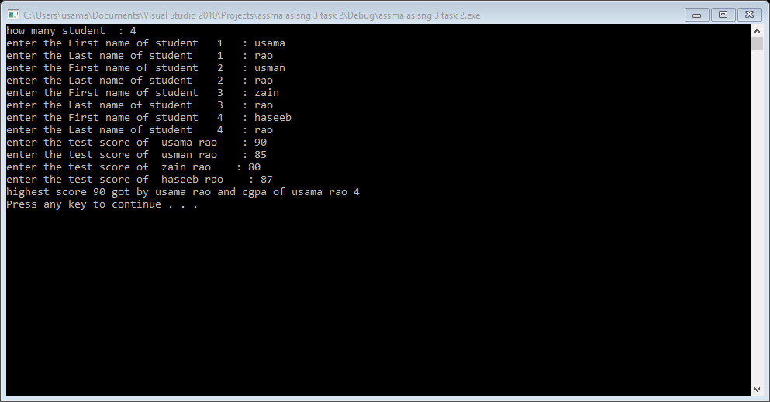

Task 5:

#include<iostream>

#include<string>

using namespace std;

struct student

{

string Fname;

string Lname;

int score;

int cgpa;

};

void input(student *ptr, int size);

void grades(student *ptr, int size);

int main()

{

int adres=0;

int size=0;

cout<<"how many student : ";

cin>>size;

student *ptr;

ptr=new student[size];

input(ptr,size);

grades(ptr,size);

system("pause");

return 0;

}

void input(student *ptr, int size)

{

for(int i=0; i<size; i++)

{

cout<<"enter the First name of student "<<i+1<<" : ";

cin>>ptr[i].Fname;

cout<<"enter the Last name of student "<<i+1<<" : ";

cin>>ptr[i].Lname;

}

for(int i=0; i<size; i++)

{

cout<<"enter the test score of "<<ptr[i].Fname<<" "<<ptr[i].Lname<<" : ";

cin>>ptr[i].score;

}

}

void grades(student *ptr, int size)

{

int match=0;

for(int i=0; i<size; i++)

{

if(ptr[i].score>=90)

{

ptr[i].cgpa=4;

}

else if(ptr[i].score>=85)

{

ptr[i].cgpa=3.67;

}

else if(ptr[i].score>=80)

{

ptr[i].cgpa=3.4;

}

else if(ptr[i].score>=75)

{

ptr[i].cgpa=3;

}

else if(ptr[i].score>=70)

{

ptr[i].cgpa=2.6;

}

else if(ptr[i].score>=65)

{

ptr[i].cgpa=2.2;

}

else if(ptr[i].score>=50)

{

ptr[i].cgpa=1.7;

}

else if(ptr[i].score>=40)

{

ptr[i].cgpa=1.3;

}

else if(ptr[i].score<40)

{

ptr[i].cgpa=0;

}

else

{

cout<<"invalid case"<<endl;

}

}

for(int i=0; i<size; i++)

{

for(int j=i+1; j<size; j++)

{

if(ptr[i].cgpa==ptr[j].cgpa)

{

match++;

ptr[j].cgpa=NULL;

}

}

}

for(int i=0; i<size; i++)

{

cout<<" cgpa of students : "<<ptr[i].cgpa<<endl;

}

cout<<"delete the same cgpa of students "<<endl;

}

Result:

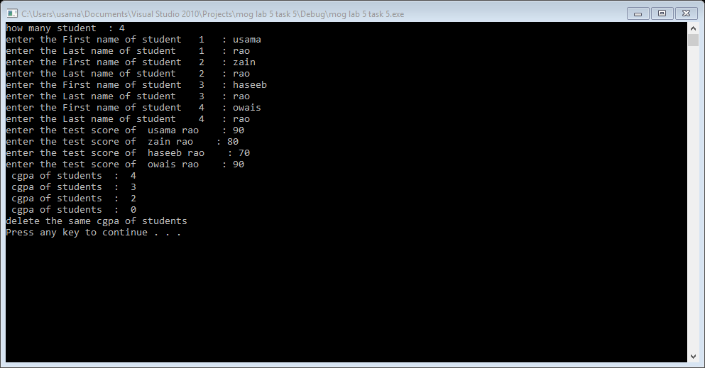

Task 6:

#include<iostream>

using namespace std;

struct time

{

int hours;

int mints;

int sec;

};

int main()

{

time t1,t2,t3;

int totalt1=0,totalt2=0,total=0;

cout<<"enter time in hours"<<endl;

cin>>t1.hours;

cout<<"enter time in mints"<<endl;

cin>>t1.mints;

cout<<"enter time in seconds"<<endl;

cin>>t1.sec;

totalt1=(t1.hours*3600)+(t1.mints*60)+(t1.sec);

cout<<"enter time in hours"<<endl;

cin>>t2.hours;

cout<<"enter time in mints"<<endl;

cin>>t2.mints;

cout<<"enter time in seconds"<<endl;

cin>>t2.sec;

totalt2=(t2.hours*3600)+(t2.mints*60)+(t2.sec);

total=totalt1+totalt2;

t3.hours=(total/3600)%24;

t3.mints=(total/60)%60;

t3.sec=(total/60);

cout<<"time : "<<t3.hours<<":"<<t3.mints<<":"<<t3.sec<<endl;

system("pause");

return 0;

}

Result:

